DOKUZ EYLUL UNIVERSITY


ELECTRICAL AND ELECTRONICS ENGINEERING DEPARTMENT

PROJECT : HAND GESTURE RECOGNITON

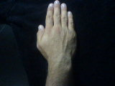

INSTRUCTOR : Asst.Prof.Dr. Güleser Kalaycı DEMİR

STUDENT NAME : İBRAHİM BARAN ÇELİK ID:2009900211

HAND GESTURE RECIGNITION

STUDENTS INVOLVED IN THIS PROJECT ARE LISTED BELOW WITH THE GIVEN PERSONAL INFORMATIONS.
Author Name : İBRAHİM BARAN ÇELİK ID : 2009900211 E-Mail: eng.ibrahimcelik@hotmail.com

Abstract: The aim was ''Getting the associated'' number for each cathegory of hand gesture.The Hand Gestures will be classified according to its thumb and according to its position on area,The process order of the project is; get the input image , make it suitable for the elimination of noise.Like grouping all the elements in the image using labelling, getting the features of our cleanedimage,height and weight of our image,central point coordinates,amount of pixel of out image, send these features to the neural network and classify it.Neural network has Back Propagation Algorithm it means corrects the error by it-self at each given prototype. All the codes of the programme were written without stock-codes which means the user can intervent each steps of our programme which is necessary.

I. INTRODUCTION
Computer recognition of hand gestures may provide a more natural human-ocmputer interface,allowing people to point or rotate a 3D model by rotationg their hands.Interactive computer games are enhanced by computer can understand player's hand gestures.Gesture recognition may even be useful to control household appliances

We distinguish two categories of gestures
- Static Gestures:Its based on particularly hand configuration and pose,its represented by single image
- Dynamic Gesture :Its a kind of moving gesture,represendted by sequence of images .
I focused on the recognition of static gestures.although mu method generalizes in a natural way to the dynamic gestures
For the broadest possible application ,a gesture recognition algorithm should be fast to compute.not to miss any importand hand gesture..

II. METHOD
There are four main steps in our project these are
- Collecting Prototype Images
- Procsessing the image:Eliminating noise feature extraction
- Getting Feature Vectors From each Cleaned image
- Training the Back Propagation NN with these features
- Check the performance of our Network

All Steps will be explained in detail below

- Collecting Prototype Images

There are normally 10 prototype image 5 of them thumb is open ,the rest is thumb is closed,
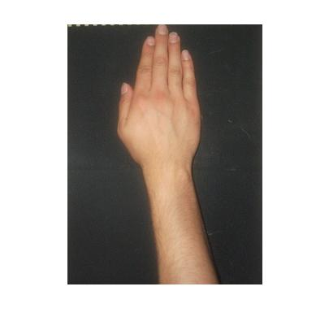
Fig. 1 .An example of taken hand images

Ten Hand Prototype normally not enought to train effectively our Neural Network,because not having suitable environment to get the image of 50 or 100 hand , Some tricks were used on out hand images,on Microsoft Windows Paint Programme. original image are taken ,its shifted up,down,right,left and its saved as differentimage,
This approximation let to have more prototype to train our network better.

- Proccessing Image
Some group of process are applied after getting the image

- Averaging image:Because of interest area is ''where the hand is'' and ''which pose hand has'' we dont need the details of our image like nails,line of hands etc, this idea lead us to eliminate the details of our picture, one of the best approximation is averaging our image;
First of all an average filter created like;
0.1111 0.1111 0.1111
0.1111 0.1111 0.1111
0.1111 0.1111 0.1111
Fourier Transform is applied to our filter;Then the image subdivided into its R G B values and Each of thems Fourier Transform were taken;then by this property of fourier transform
F(x).F(y)=f(x)*f(y)
Each R G B matrices and Transformed Averager matrice are multiplied ,then each R G B results are summed, the result image will be like;
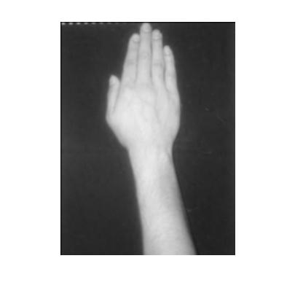
Fig. 2 Example of Averaged Image
As we can see from the figure Details on the image is decreased, Amuont of R G B differences between object(hand) and back ground is increased,
Now we go next step;

- Converting image to black-white image:
This conversation lets us to have a image matrices that is created zeros and ones,it will lead us to much simpler mathematical operations and efficiency in time, the result image will be like in below
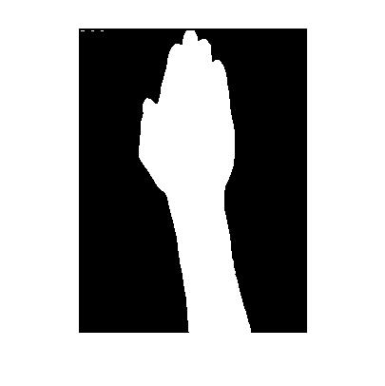
Fig. 3 Example of Cleaned Image
It can be seen that there are some noices on our image upper and left corner,the next step is about the elimination of them

- Elimination of noise: Connected componend algorithm was used in the projec ,what ever whic hand is used in our image when C.C. algorithm is used in image(after B.W) each non connected component are labelled in our image like:background:1,hand:2 noise :3 goes on...
When we check we can see the labes 1 always for the background label two is always for the hand but that method wasnt used in the project, according to me much better is used like;

''Kill all the labels these number of pixels is smaller than 500'' this algorithm lets if by the mistake label 2 is associated to any noise it would lead to kill the hand,(would made it black) so in that algorithm the comparison is based on the number of pixels in each component

- Getting the Feature of out image:Because of all classicifation property of our N.N is is based on ''Where The Hand Is'' and ''Thumb Is Closed or Not'' by these necessity Center Point of Hand, Weight and Height of hand , Number Of Pixel of Hand Features are enought to get the identical classification

- Preparing The Neural Network: There are 2 times changing on the Type Of Neural Network ,First of them was the Association Neural Network,then because of programmers algorithm problem and then beacuse of some Networks itself problem İts changed later on Back Propagation Algorithm;
Lets investigate them one by one

- Auto Association Neural Network:
Working Principle of it,Giving the noisy image and getting the most approximate image from data base
This method is based on Shape Of Image
Lets investigate the problems one by one;
Programmers Problem: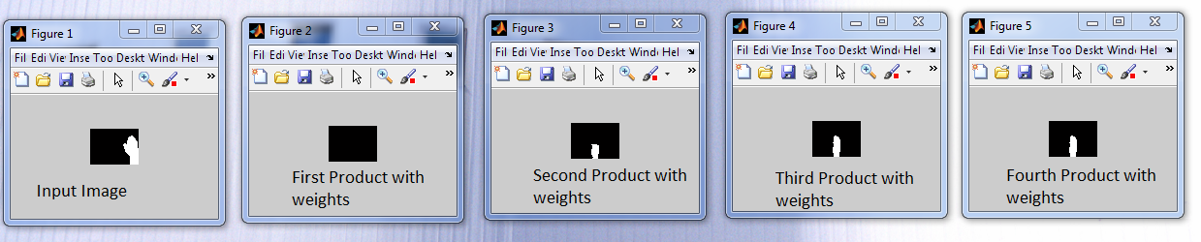
Fig. 4 Results of auto association neural network

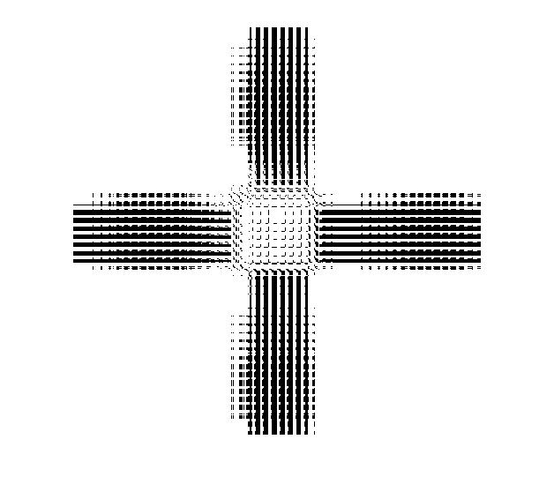
Fig. 5 Weight matrix of auto association neural network

- Back Propagation Algorithm N.N
After Getting the unwanted results from the Auto association Neural Network , it directed me to the trusted and certain method that is not based on Shape Of Image, Its based of Feature Of Image ,The structure of ouf Neural Network is below

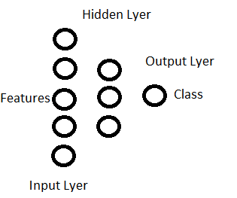
Fig. 6 Structure of back propagation neural network
Classes are given according to list below;
1 closed mid
2 closed up
3 closed down
4 closed right
5 closed left
6 open mid
7 open up
8 open down
9 open right
10 open left

III.RESULTS
Lets investigate our results;The results after first epoch of training set in the below

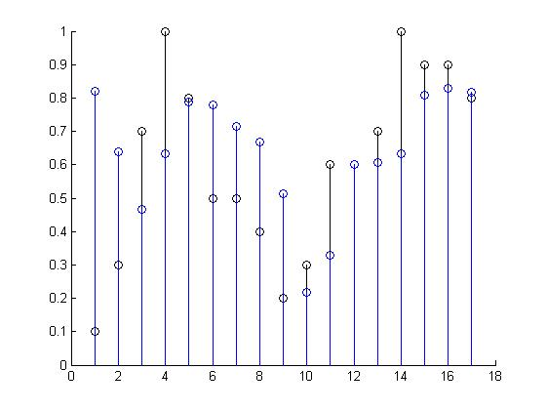
Fig. 7 Result of training set of B.P. neural network after one epoch
Decided=black
Actual=Blue

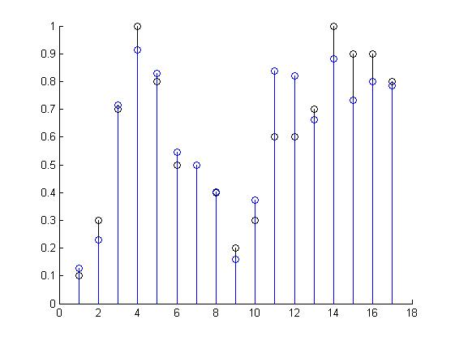
Fig. 8 Result of training set after thousands of epoch
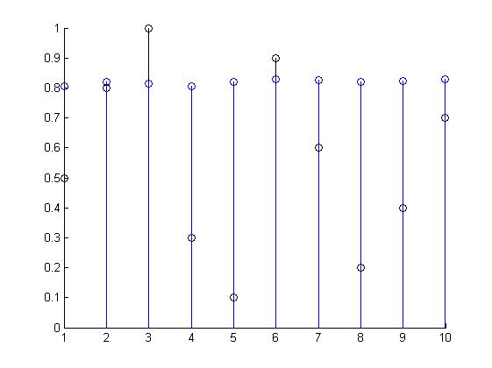
Fig. 9 Results after first epoch of validation set

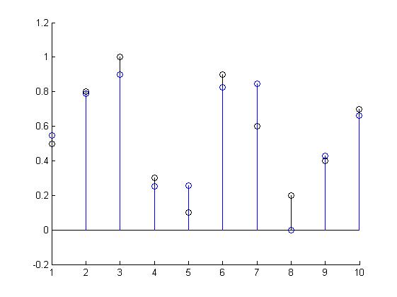
Fig. 10 Result of training set after thousands of epoch
We can see the difference between two graph its hopefull;
Now lets see what happened while training; epoch by epoch
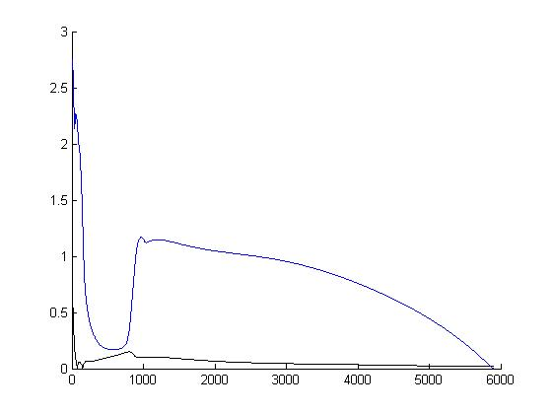
Fig. 11 Results of Error of each epoch.Black one is the training set blue one is the validation set.
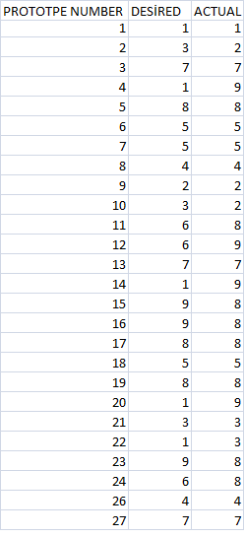

Table 1 Results of Neural Network

As it can be seen from figure7 to figure10 there are big improving of weights and results. Nearly 70 percent of our inputs classification is succesfull.

IV. DISCUSSION
Before the discussing Back Propagation lets have a look ,
why we had problems with Auto association N.N
As It can be seen from the results ''Because of always the second iteration goes the zero, all the hands goes always same hand its not important what ever which hand isused''
The things that may lead that problem one of them is not enought input prototype;Because 10 hand were used for that ,lets chech the weight matrices

Other problem may because of size of image it was 320*240;
In the end the the smallest probabilty source of problem is the Programmers Mistake

When we check the weight matrices image it can be seen that it doesnt full fill all the area ,this idea lead me to the probabilty one.

What sould we have if these problems were handled,
according me nothing,beacuse i need logical outputs for each hand gesture..lets suppose that that algorithm was successfull and i got a good approximation for each input,then i would need another Neural Network

Algorithm because I would need approximation convert to certain values like it would be so hard because of each hand gives differend approximation would give thousand of approximation these must be classified
If we turn back out Back Prop.Algorithm it can be seen clearly there are some unwanted results with wanteds..
There are nearly 30 percent of errors in our total hand; these error are because of inputting inadequate pattern,
Beside Some of results are perfect there are still so many distance between some outputs and decided outputs ;
Normally there are ten non-tricked hand image,it means all the ten were taken from directly camera ,not using paint, but there are all 27 hand image it means there are 3 missing image, Class 6 and Class 7 have still big difference between Desired outputs and Actual outputs..these differences may be caused of the missing pictures.It would be better if the programme was compared with another programme that is written by steady codes
.Even our programme has that disadvantage it also has good properties like working fast, can be interventioned because of writting with nonsteady codes,the programs feature extraction part has an extra property its the preparing data matrices after feature extraction,that will be seperated into training and validation sets in the feature,

V. CONCLUSION
Actually According to me that project was a good project for a students who cares about combining digital image proccessing neural network and controlling,because after completing that project the programmer can feel that he or she improved itself in these area,by using and thinking numerous of different algorithm and tecnics
After that programmes environment (like setting cameras in a box) are build and resulted succesfully we can embedd it another system to control, like setting contuctor between two system or putting a programmed pic there,actually my aim is building an surgery robot hand if its succesfull and controlling that robot hand with that Neural Network Project

ACKNOWLEDGMENT
We would like to give our special thanks to Asst. Prof. Dr. Güleser Kalaycı Demir for her supports.

REFERENCES
[1] Digital Image Proccessing -Rafael C. Gonzales

[2] Berlin Chen Lecture notes: Normal University, Taipei, Taiwan, ROC. http://140.122.185.120

